Experiment8: Steering Angle Variation in MIMO Beamforming Using MATLAB
Aim
To analyze the effect of steering angle variation in a MIMO beamforming system by studying
steering angle, array gain, and beam direction error using MATLAB.
Objectives
1. To analyze the steering angle of a MIMO beamforming system by directing the beam
towards different target directions using MATLAB.
2. To compare the array gain achieved for different steering angles in a MIMO beamforming
system using MATLAB.
3. To evaluate the beam direction error between the desired steering angle and the actual
beam direction using MATLAB.
Software Required
• MATLAB
Theory
MIMO (Multiple-Input Multiple-Output) beamforming enhances wireless communication by
employing multiple antenna elements to direct transmitted energy toward a desired user. By
adjusting the steering angle through appropriate phase shifts, the beam can be focused in different
directions, improving signal strength and reducing interference. Important performance
parameters include steering angle, array gain, and beam direction error, which collectively
determine the effectiveness of beam steering in modern wireless systems such as 5G NR.
Objective – 1
Analyze Steering Angle (Degrees)
Analyze different steering angles of a MIMO beamforming system using MATLAB. Observe how
the beam can be directed toward various target directions by varying the steering angle.

MATLAB Code:
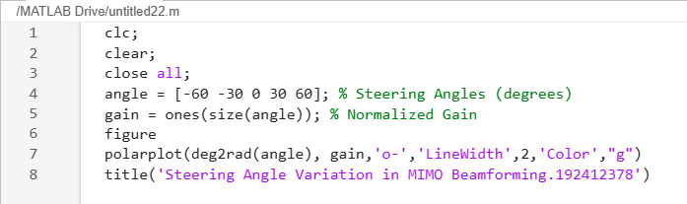
Expected Output
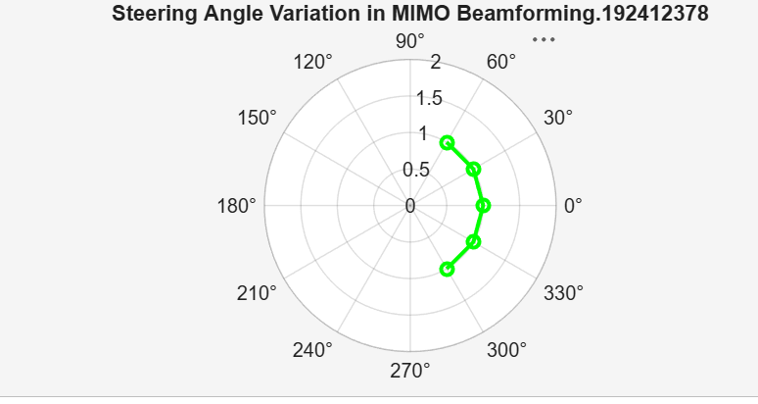
• Plot showing different steering angles.
• Beam steering visualization.

Objective – 2
Compare Array Gain (dB)
Compare the array gain obtained at different steering angles using MATLAB. Observe the
improvement in signal strength achieved through beamforming.

MATLAB Code:
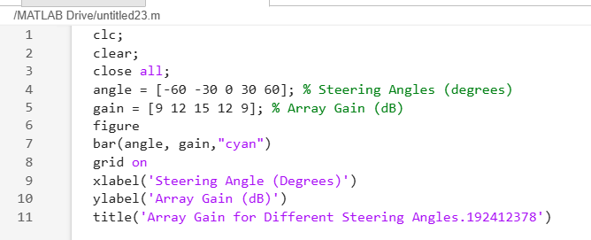
Expected Output
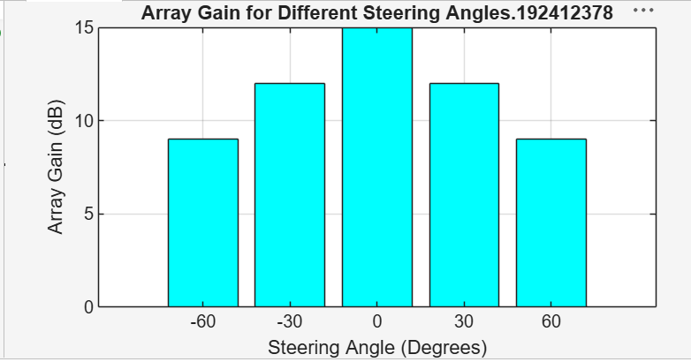
• Bar graph showing array gain for different steering angles.
Objective – 3
Evaluate Beam Direction Error (Degrees)
Analyze the difference between the desired steering angle and the measured beam direction using MATLAB
. Compare the beam direction error for various steering angles and evaluate the beam
steering accuracy.

MATLAB Code:
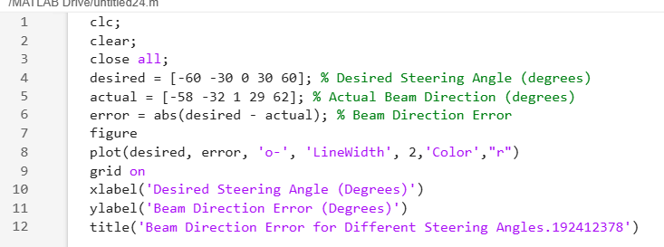
Expected Output
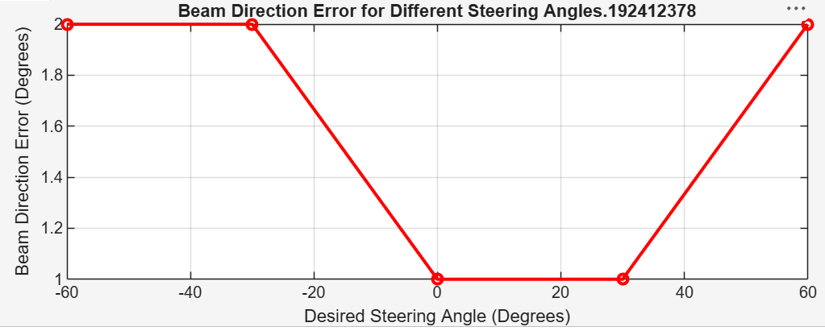
• Line graph showing beam direction error versus steering angle.
Result
The MATLAB analysis successfully demonstrated steering angle variation in a MIMO
beamforming system. The results showed that beam steering effectively directs the transmitted energy toward different angles, while maintaining high array gain and minimizing beam direction error.

